1. Introduction
"If you're competitor-focused, you have to wait until there is a competitor doing something. Being customer-focused allows you to be more pioneering."—Jeff Bezos

Over Q4’22 and Q1’23 we conducted a deep dive across multiple Chronicle customer touchpoints (SIMs, Office Hours, 1:1 customer interview, usage metrics, metrics survey). We wanted to test and examine combined analysis of this data and what insights (e.g. correlations, contradictions, problem areas, solutions) it may provide in regard to assessing data consistency, comprehension, and accuracy.

The purpose of this document is to: 1) identify key insights of the SIM data, usage metrics, and the metrics survey; 2) identify ways that the information may be useful; 3) what improvements are needed; and 4) discuss next steps of the issue. Ultimately, the desired result is that this information will help our team develop a cohesive strategy across metric owners, application owners, data services, and decision makers to ensure metrics are used effectively for decision making.

2. Problem
“A problem well stated is a problem half solved.”– John Dewey

From the deep dive across multiple customer support touchpoints (SIMs, Office Hours, 1:1 customer interviews) we identified that 25% of our customer contacts are due to issues/questions about metrics. These questions point to underlying problems about users’ ability to comprehend and drive effective insights from metrics. Currently, metric owners, application owners, and data service owners have a siloed and reactive approach towards these issues (focused on reducing customer touch points).

How do we create a cohesive data strategy across metric owners, application owners, data services, and decision makers to ensure that metrics are used effectively to: 1) turn this data into intelligence; 2) delivering the right recommendations at the right time; 3) unifying data to deliver a higher level of precision analytics; and 4) improve data consistency, comprehension, and data accuracy?

3. Key Issues/Insights
“We cannot solve our problems with the same level of thinking that created them.”—Albert Einstein

Throughout the analysis, we have gained many insights on the data and information that we have gathered. In this section, we will use the SIM data, usage data, and survey data, we will discuss the results, similarities, differences, and findings (what the data is saying and what the data isn’t saying).

List of Metrics Interacted with the Most
The most interacted metric information was important because it will give us insights into what top metrics those surveyed use on a daily basis. This can help us with two things: 1) help us identify focus in on the important metrics to users; 2) help us examine the metrics customers are having the most issues with the metrics that they use most often; and 3) identify data inaccuracy and how they are triggered. If metrics used most often are also having issues, this can help us focus in on issues of each of these metrics. The top 21 metrics that the survey population interacted with most often are 1)PCOGS (~43%), 2)ACU (~22%), 3)NETPPM (~19%), 4) Confirmation Rate (~17%), 5)ROOS (~17%), 6) ASP (~17%), 7) Revenues (~16%), 8) LBB (~14%), 9) Deal Ops (~14%), 10) Net Receipt (~13%), 11) Conversion Rate (~12%), 12) Net Order (~12%), 13) CM (~11%), 14) GMS (~11%), 15) GV (~10%), 16) CP (~9%), 17) Net Order GMS (~9%), 18) OIH (~9%), 19) VCR (~7%), 20) IDQ (~6%), 21) CPPU (~5%). SIM data showed similar results. The usage data highlighted Product Cogs AMT, Revenue Share, total orders product sales, quantity shipped, GMS, contribution profit, item name, total ordered units DDAA ordered GMS, and product GMS as the top metrics viewed by customers.

List of Metrics with the Most Issues
The survey identified metrics individuals surveyed reported having the most issues with were are 1) ROOS (25.90%), 2) Deal OPS (22.30%), 3) Net PPM (20.14%), 4)OPS (12.95%), 5) LBB (9.35%), 6) CR (7.19%), 7) GV (6.47%); 8)SNS (6.47%); 9) VCR (5.76%), 10)PCOGs (5.04%),11) ASIN (5.04%), 12)OIH (4.32%), 13) ASP (4.32%), 14) B2B (3.60%), 15) CM (2.88%), 16) IDQ (2.88%), 17) FTAC (2.88%), 18) Buyable (2.88%), 19) GM (2.16%), 20) Fill Rate (2.16%), 21) CP (1.44%), 22) IBO (1.44%), 23) AB (1.44%), and 24) DAC (0.72%). This information is important because it shows which metrics our team should look closer at and what are the root causes of these issues. SIM data showed similar results. The usage data does not directly identify which metrics customers have the most issues with, but these issues can be identified in metric usage (e.g. low usage may equate to a metric issue, or high usage may equate to a metric issue).

Root Causes of Issues
SIM data, usage data, and the survey data were able to identify a few root causes behind metric issues. The survey data and usage data were aligned. They both reported that the top four root causes reported were: 1) data quality (38.85%); 2) upstream data source issues (37.41%); 3) there are multiple values/definitions/versions for the same metric (33.09%); 4) Lack of education about the metric (e.g. definition, source, logic) (21.58%). While the SIM data reported that data availability, data discrepancy, and data definition/comprehension as the top issues that were reported. All data sources are outlining similar root causes such as data quality, data discrepancy, education, and data comprehension. This confirmation of all data sources is confirming that these are root causes that we should look into.

Comprehension
The issue of data comprehension is a very prominent issue that was identified in Data comprehension can sometimes be a culprit for many different issues. According to the SIM data, 51.1% SIM tickets are bucketed under user knowledge. 40% of theses comprehension issues can be addressed through improved documentation surfacing through tools such as wiki, sage, and a chatbot. The SIM data also highlights that metric comprehension correlates to the top usage metrics (OPS/GMS, GV, Net PPM, PCOGS, Net Receipt, ROOS, Deal OPS, Confirmation Rate, IDQ, Inventory).

Some insightful aspects of the usage analysis show that user education correlates to specific demographics such as tenure, level, and department. The Turismo Metric Usage Dashboard the majority of requests come from customers with less than a year in their current position. Additionally, the usage board also shows that L4s (2380) frequent metrics more often followed by L5s (1205), L6s (586), L3s (291), L2s (281), L7s (99), L8 (11), and L10s (1). This means that L4s are using the site more often. This could be because they need access metrics multiple times a day for their current position, or this may also mean that they are having difficulty or trouble using a metric. Lastly, another key insight that the metric usage dashboard shows is that specific departments frequent metrics more often (e.g. EU SVS (2007), Paid Services Vendor (1105), JP SVS (382), VSM-Hardlines-VAR (313), EU Retail (294), VSM-Consumables (229), EU Retail TCEE Central (EUS) (201), EU Consumables Central (EU5) (179), JP Central Retail Services-VAR (75), and JP Retail Life & Leisure (65). What this information further establishes that the customer education level correlates to current position or level, tenure, and department. Although we already have tools (e.g. data dictionary, FAQs, a great help application) we may not be fully responding to the customer education issue. An emphasis on onboarding training as well as continued training on metrics and systems might be necessary to invest in.

Data Accuracy
The SIM data shows that data accuracy (data discrepancy) stems from two issues. First, there is an existing data difference between Turismo and other tools (e.g. daily order, procurement portal, cost portal). To fix this issue, our team will need to conduct further research as well as work with the tools owner and inform the overlap users on the expected gap. Secondly, the data differences between Turismo and an ad-hoc query or dashboard owned by the BI team should provide users better visibility on Turismo definitions.

Data Availability
SIM data has identified two main issues with data availability: 1) at the beginning of every beginning of metric period (week, month, year), users continually inquire that metric X is not available for week Y. The SIM data shows that this happens to users who are RBS with job title Catalog Specialist or Translation Associate; and some VMs. To solve this, our team needs to: 1) provide users better visibility on when metrics are available is available; and 2) when users are inquiring about no data in Turismo for certain vendor codes or brands code (similar user group), we need to help bridge the gap and help users understand why their code doesn’t return data in Turismo.

Number of Issues
The survey responses to this question were 0 to 5 issues per week (12.23%), 6 to 10 issues per week (59.71%), and 11 to 15 (16.55%). This information conflicts with SIM data, 75% of users raise only 1 SIM ticket per year. This conflict in information shows that there is an issue with the current situation. These responses are letting us know that customers are having multiple problems a week and not submitting SIM tickets to resolve the issue. This could be because 1) users do not feel like the SIM process works; 2) users do not feel as though they are getting a timely response to their request; 3) users find solutions on their own using the current help applications provided; 4) users receive help from a team member or other source; or 5) users give up and do not care to look into the issue further. Further research should be done in this space to find out what those surveyed who have 0, 1-2, 3-5, 6-10, +11 issues a week. We need conduct further research and determine if users 1) open a SIM; 2) are not opening up a SIM ticket to solve the metric issues; 3) interview those with 0 issues and find out what their best practices are; 4) interview those with1-2, 3-5, 6-10, +11 to identify issues and what support they need. Additionally, we should look into what do they do with the metric information that they have? Answering these questions could help identify appropriate solutions to the metric issues that they are experiencing.

4. How is this information useful?
“There’s no use talking about the problem unless you talk about the solution.”—Betty Williams

This information is extremely useful. These insights will help us measure and act in creating viable and sustainable solutions. Additionally, we will be able to institute quality monitoring that will help us respond to challenges before they become full-blown crisis. Effective quality monitoring will allow our organization to be proactive rather than reactive and will support the organization to maintain best practices over time.

This deep dive effort has also allowed our team to more effectively determine the cause of problems. The data and insights generated during this time will help to visualize relationships between what is happening in different locations, departments, and systems. Looking at these data points side-by-side allows us to develop more accurate theories, and put into place more effective solutions.

6. Next Steps
“A problem is a chance for you to do your best.”—Duke Ellington
For the next steps, we plan to first conduct 1:1 with users to explore approach to help improve the current data issue to answer questions: a) when they have data question, what do they do, submit SIM; b) do you think you need data faster? how fast? why?; c) which way you prefer to get info or educate for your role (e.g. video, wiki, sage); d)how is Turismo/metrics embedded in your onboarding plan? how did you learn Turismo; e)which metric help them “identify opportunity” and “improving “efficiency. ”
Secondly, we also plan on implementing a weekly/monthly survey to measure user sentiment of metrics (e.g. “Do you think data quality is improved?”).
Lastly, we plan to research the viability of a customer education program. This program would be responsible for developing customer how to videos, developing a customer metric onboarding program, working with development teams on making help functions and various help applications better for users, and much more.

FAQs
“A sum can be put right: but only by going back till you find the error and working it afresh from that point, never by simply going on.”—C.S. Lewis

Appendix A: Survey Results
“A sum can be put right: but only by going back till you find the error and working it afresh from that point, never by simply going on.”—C.S. Lewis

A little bit about the survey?
The survey was launched in January – February 2023. 109 survey invitations went out to metric owners, application/data service owners, and metric users. Our team received 139 survey responses which was ~128% response rate. The response rate itself was an insight. A survey response rate of 50% or higher should be considered excellent in most circumstances. A high response rate is likely driven by high levels of motivation to complete the survey, or a strong personal relationship between business and customer. Additionally, achieving an acceptable survey response rate is important because too low a figure can give rise to sampling bias, particularly if the number of nonresponses is unequal among survey respondents. Because our response rate was excellent, this provides four major benefits such as higher data quality and accuracy. Additionally, the high response rate shows that the survey was easy to respond to, which means that there is a greater the chance respondents will answer truthfully. Badly designed surveys will see people dropping out or clicking through senselessly. Therefore, we can say that our survey questions were good, people wanted to take our survey, and our data accuracy and quality is high.

Who took the survey?
The survey population is made up of metric users (~84.78%), application owners (~9.42%), data service owners (~7.25%), metric owners (~5.8%). This information tells us that metric users were the largest population. As a result, the survey output is expected to primarily reflect the voice of the metric user.

What metrics do those surveyed interact the most with?
The top 21 metrics that the survey population interacted with most often are 1)PCOGS (~43%), 2)ACU (~22%), 3)NETPPM (~19%), 4) Confirmation Rate (~17%), 5)ROOS (~17%), 6) ASP (~17%), 7) Revenues (~16%), 8) LBB (~14%), 9) Deal Ops (~14%), 10) Net Receipt (~13%), 11) Conversion Rate (~12%), 12) Net Order (~12%), 13) CM (~11%), 14) GMS (~11%), 15) GV (~10%), 16) CP (~9%), 17) Net Order GMS (~9%), 18) OIH (~9%), 19) VCR (~7%), 20) IDQ (~6%), 21) CPPU (~5%). The most interacted metric information was important because it will give us insights into what top metrics those surveyed use on a daily basis. This can help us with two things: 1) help us identify focus in on the important metrics to users and 2) help us examine the metrics customers are having the most issues with the metrics that they use most often. If metrics used most often are also having issues, this can help us focus in on issues about why they are having these issues with these metrics.

What is the reason for those interactions?
The top reasons for those metric interactions those surveyed reported were analysis (~82.01%), reporting (~79.14%), performance monitoring (~78.42%), decision making (~64.03%), auditing (~26.62%). Note, the survey question was a select all question. So, some of those surveyed could have selected multiple reasons for metric interactions. The top reasons for metric interactions also provide good information. This information tells us what business reasons these metrics are being used for as well as the importance of these metrics in surveyed members activities.

What decisions do these metrics influence?
The next question refers to what decisions do these metrics drive. This question points out that identifying opportunity (84.89%), improving efficiency (74.82%), cost saving (51.80%), and other (7.91%) are the decisions that these metrics they use drive. For other, the other decisions identified that were not listed were defect resolution (0.72%), if values are displaying correctly (0.72%), growing GMs (0.72%), opening up prioritizing requests for improvement (0.72%), identify root cause (0.72%), selecting priority vendors for additional SSCM support (0.72%), provide business intelligence (0.72%), and creating reports for retail community (0.72%). Here the data shows the value of these metrics and how these metrics influence everyday business decisions. This is very important because it further sheds light on the importance and need for accuracy of these metrics.

Which metrics do those surveyed have the most issues with?
The top 24 metrics individuals surveyed reported having the most issues with were are 1) ROOS (25.90%), 2) Deal OPS (22.30%), 3) Net PPM (20.14%), 4)OPS (12.95%), 5) LBB (9.35%), 6) CR (7.19%), 7) GV (6.47%); 8)SNS (6.47%); 9) VCR (5.76%), 10)PCOGs (5.04%),11) ASIN (5.04%), 12)OIH (4.32%), 13) ASP (4.32%), 14) B2B (3.60%), 15) CM (2.88%), 16) IDQ (2.88%), 17) FTAC (2.88%), 18) Buyable (2.88%), 19) GM (2.16%), 20) Fill Rate (2.16%), 21) CP (1.44%), 22) IBO (1.44%), 23) AB (1.44%), and 24) DAC (0.72%). This information is important because it shows which metrics our team should look closer at and what are the root causes of these issues.

Which are the root causes of these issues?
The root causes of these issues were 1) there are data quality issues with the metric (metric value is perceived to be incorrect)(38.85%), 2) upstream data source issues (37.41%), 3) there are multiple values/definitions/versions for the same metric (33.09%), 4) Lack of education about the metric (definition, source, logic etc.)(21.58%), 5) the metric is complex (calculation, methodology, definition) for users (20.86%), 6) metric is very new and users are not familiar with the metric (9.35%), metrics are new or undergo definition changes very often, 7) metrics are new or undergo definition changes very often (7.19%), 8) new to job (2.16%), 9)Metric is delayed (0.72%), 10) metric values are wrong (0.72%), 11) do not know how to use the metric (0.72%), and 12) do not understand the reason behind the changes to this metric. The identification of these root causes helps us better understand the problem. The survey results are also saying what root cause of metric issues that we need to focus on are data quality, data sourcing, multiple metric understandings, lack of education, and metric complexity. This will require an additional in more depth root cause analysis (RCA) to help identify the appropriate solutions to the problem.

How many metric issues or questions are seen each week?
The survey responses to this question were 0 to 5 issues per week (12.23%), 6 to 10 issues per week (59.71%), and 11 to 15 (16.55%). These responses are letting us know that customers are having multiple problems a week. The majority of those surveyed are having 6 to 10 metric issues a week. Although there are not as many SIM tickets as the number issues reported, this does not mean that those surveyed will open a SIM ticket every time they have issues. Further research should be done to find out what those surveyed are doing if they are not opening up a SIM ticket to solve the metric issue. Additionally, we should look into what do they do with the metric information that they have? Answering these questions could help identify appropriate solutions to the metric issues that they are experiencing.

What is the impact of the issues?
The survey responses identify the following as impacts of metric issues: 1) inaccurate analysis (53.96%); 2) inaccurate reporting (58.99%); 3) bad decision making (15.11%); and 4) other (15.11%). Some issues listed under other include delay in performance monitoring, time loss, delayed reporting, application errors, delays in decision making, added barriers to decision making, and the over-abundance of information is being considered for an undue amount of time. When put together, the survey information is telling us that inaccurate metrics, leads to inaccurate analysis and is producing misleading results causing decision makers to make poor decisions based on bad data. If information facilitates decisions regarding allocation of resources and thereby assist an organization in pursuit of its objectives, our team needs to deep dive this issue further and make sure that we are doing our best to provide accurate metric data.

4. Survey Insights
The survey was able identify some key insights. First, the excellent survey response rate of 12 survey response was likely driven by high levels of motivation to complete the survey, or a strong personal relationship between business and customer. Because our response rate was excellent the response rate leads to higher data quality and accuracy and a greater the chance respondents answered truthfully. Therefore, we can say that our survey questions were good, people wanted to take our survey, and our data accuracy and quality is high.
From the survey, we are also able to develop a list of the top 21 most interacted metrics and a list of the top 24 metrics those surveyed had the most issues with. The top reasons for those metric interactions those surveyed reported were analysis, reporting, performance monitoring, decision making, auditing. This information will tell help us identify focus in on the important metrics, and help us examine the metrics customers are having the most issues with the metrics that they use most often. If metrics used most often are also having issues, this can help us focus or prioritize issues and develop appropriate solutions.

5. Next Steps
We have access to 30K+ Amazonians and 65K+ Selling Partners that use our metrics and tools to drive decisions. This access enables us to have insights into their individual decision-making framework, the problems they face, and the actions they take. However, in order to tap into these insights, we need direct interactions with users. By interacting with users when they have problems with metrics and tools, we will be able to spot trends that drive decisions, get a clear idea of what to focus on in the current situation. We propose that our customer insights team prototype session uses this survey information to: 1) develop a deep understanding of our customers by comparing this survey data with both metric usage data and SIM data, 2) use the insights gathered from #1 to develop a list of 15-20 metrics to monitor during 16 week prototype period, 3) develop a prototype plan (e.g. how will we monitor these metrics, what KPIs will we measure, what identifiable triggers causes metric inaccuracy), 4)convert customer anecdotes into insights that can be used to drive improved decisions, 5) help individual customers answer questions and resolve issues, 6) identifying unique customer behaviors that improve decision making, 7) understanding when and how to guide customers in their decision-making process, and 8) create and maintain a richly descriptive, unified view of customers, issues, and, potential insights — a view made up of all data types and sourced from all data repositories, irrespective of departmental siloes. This data can be used by tools across Amazon to drive improved efficacy for Amazonians.

What does this mean for our customers?
Through customer interactions, we will be able to identify developing decision-making patterns (use of X metric to solve Y problem) faster and surface this to relevant customers who are currently unaware of this. Thus, we will accelerate decision making for our customers. Additionally, our customers will now have access to information from Amazon “experts” without having to search and scour through multiple sources (like Sage, Merlin), improving their efficacy.

How is this strategy different from what we do today? Why do we need a different strategy?
Our current strategy, revolves around resolving customer issues and the success of our Customer Support is measured based on speed of issue resolution. Our new strategy differs in its inputs as well as outputs (or outcomes). The outcomes for our new strategy is improved insight generation (faster and better) leading to better decision making. In terms of inputs, we currently only see customer SIMs for Chronicle to identify customer issues, whereas with our new strategy, we will use a variety of sources such as SIMs across SPIF, different customer channels (such as slack, email), central sources (Merlin, Sage) to identify customer issues and behavior. Also, currently we do not catalog findings from customer issues and focus on resolving issues as opposed to identifying customer behavior patterns and cataloging them in a central location for easy consumption.

Appendix B: SIM Data Findings

SIM data analysis
Scope: SIMs created since 2022 Jan till 2023 Jan.
Insight 1: 51.1% SIM are under user knowledge. ( within User Knowledge, 40% of them can be addressed through improved documentation surfacing through wiki/sage/chatbot etc.)
Goal: reduce time of answering those repeatable questions to X.
User Knowledge | 1398 | 51.9%
Analytics Bug/Production Issue | 359 | 13.3%
Data Issue | 302 | 11.2%
Metric/Slice Request | 147 | 5.5%
Analytics Feature Request | 121 | 4.5%
Business Planning Bug/Production Issue | 105 | 3.9%
Permission | 79 | 2.9%
3P Data Issue/Request | 51 | 1.9%
Turismo Customer SIM Folder | 48 | 1.8%
Business Planning Feature Request | 30 | 1.1%
Financial Planning Bug/Production Issue | 12 | 0.4%
Finance Customer Folder | 12 | 0.4%
Bug/API Error | 9 | 0.3%
Feature Request | 6 | 0.2%
Home Feature Request | 5 | 0.2%
Financial Planning Feature Request | 3 | 0.1%
RTIP to Booker D_MP | 3 | 0.1%
Data Dictionary Feature Request | 3 | 0.1%
Fortune Metrics / Slice Intake Requests | 1 | 0.0%
Grand Total | 2694 | 100.0%
Insight 2:
1650 user asked question through SIM in 2022 / 25K total users (how many are repeated users??) = 7%
75% users ask only one question.
20% users asked raise SIM 2-3 times.
vs Survey result
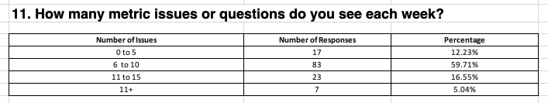
Number of SIMs | User Count
1 | 1240 | 75.06%
2 | 241 | 14.59%
3 | 96 | 5.81%
4 | 30 | 1.82%
5 | 14 | 0.85%
6 | 8 | 0.48%
7 | 4 | 0.24%
8 | 3 | 0.18%
9 | 1 | 0.06%
10 | 2 | 0.12%
11 | 1 | 0.06%
12 | 3 | 0.18%
13 | 1 | 0.06%
15 | 2 | 0.12%
17 | 2 | 0.12%
19 | 2 | 0.12%
23 | 1 | 0.06%
34 | 1 | 0.06%
Grand Total | 1652
Insight 3: Data Availability, Data Discrepancy and Data Definition/Comprehension are top three main issues for user SIMs.
Within Data Availability, it has two main issues,
1) every beginning of week/month/year, users will keep inquiring metric X is not available for week Y. (mainly uses are RBS with job title Catalog Specialist or Translation Associate; and some VMs) ->> Need to give user visibility on when metric is available
2) users are inquiring no data in Turismo for certain vendor code or brand code. (similar user group) ->> Need to help user understand why your code don’t return data in Turismo.
Within Data Discrepancy, it has two main issues,
1) data difference between Turismo and other tools, daily order, procurement portal and cost portal ->> Need to work with tools owner and inform the overlap users on the expected gap.
2) data difference between Turismo and ad-hoc query or dashboard owned by BI team. ->> Provide user visibility on Turismo definition
Within Data Definition/Comprehension, it is mainly around the top usage metrics, (OPS/GMS, GV, Net PPM, PCOGS, Net Receipt, ROOS, Deal OPS, Confirmation Rate, IDQ, Inventory) ->> metric governance group with EU/NA/JP with goal to ensure data accurate, updated and comprehensive
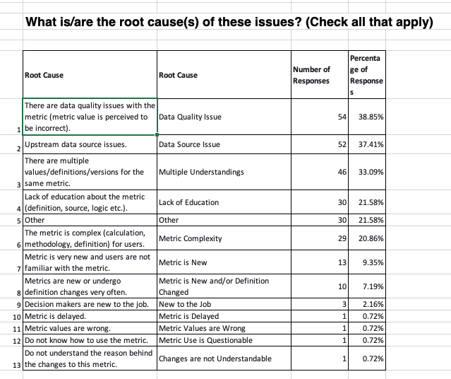
Tree map view:
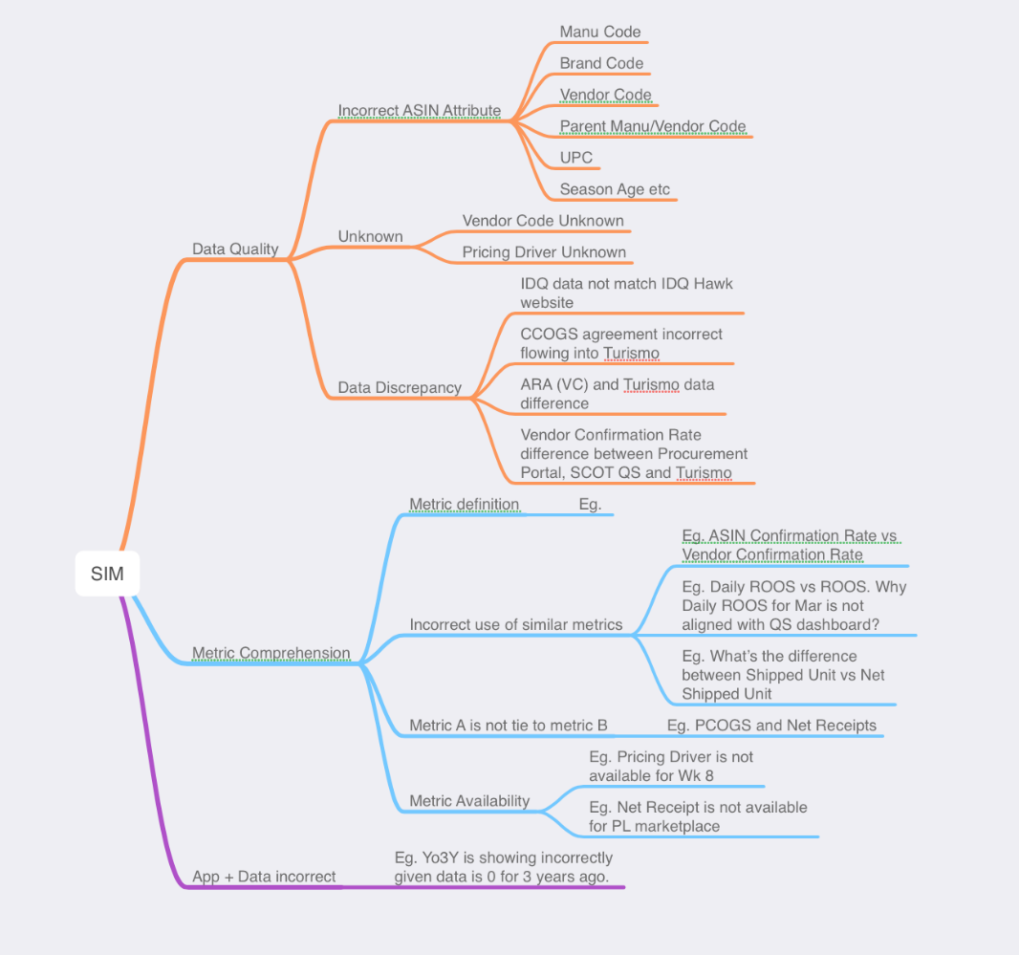
- Data Quality issue
  - asin attribute wrong
    - Manu code:[seeing the wrong manufacturer codes in the reporting]
      - https://issues.amazon.com/issues/TURISMO-9409
  - unknown/missing/null
    - unknown vendor code:[Unknown vendor bucket]
      - https://issues.amazon.com/issues/TURISMO-9191
    - unknown pricing driver: [Pricing Driver = UNKNOWN drives majority of ASP decline.]
      - Need to understand what feeds the "UNKNO" - "Unknown" vendor bucket. It is a major concern in SA since the CCOGS don't appear to feed it. Result is we're at 1.7MM USD with ProcM of -10% => major loss for Retail.
      - https://issues.amazon.com/issues/TURISMO-7885
  - Data Discrepancy
    - IDQ data not match IDQ Hawk website
      - https://issues.amazon.com/issues/TURISMO-8843
    - CCOGS agreement incorrect flowing into Turismo.
      - https://issues.amazon.com/issues/TURISMO-9351
    - ARA vs Turismo
      - Vendor says that there is PCOGS difference between the report (AVS Report) extracted by Turismo and Vendor Central. What is the reason and which one is more accurate for vendor to follow up?
      - https://issues.amazon.com/issues/D59130113
    - Procurement Portal vs Turismo
      - Net Receipts Discrepancy Between Turismo and Procurement Portal - ASIN B08BMGRMMF
        - https://issues.amazon.com/issues/TURISMO-9627
      - Data discrepancies between Procurement Portal vs. Turismo Analysis, prior week - Vendor Confirmation Rate (Procurable)
        - https://issues.amazon.com/issues/TURISMO-8493
  - Data processing error: Duplicate data
    - https://issues.amazon.com/issues/D60130840
- Data + App incorrect
  - Yo3Y is showing incorrectly given data is 0 for 3 years ago
    - https://issues.amazon.com/issues/P76848138
  - metrics naming confusion across application and region(JP)
- Metric Comprehension
  - metric definition
    - Can you share how "Retail Fast track Glance View Count" and "Retail LBB FTI%" are calculated in Turismo
      - https://issues.amazon.com/issues/TURISMO-8257
  - similar metrics:
    - ASIN Confirmation Rate vs Vendor Confirmation Rate
  - metric availability
    - Not able to see Week 47 Metrics
      - https://issues.amazon.com/issues/TURISMO-9514
  - metric a is not tie back to metric b
    - PCOGs and Net Receipts: We conducted an audit from the vendor's (code HEHE9, GL Grocery 325) Easter seasonal buy. We are noticing of the 11 ASINs, 3 ASINs had more Gross Shipped Units YTD than Net Receipts Units YTD. This should be impossible, as we only inbounded the products for the first time this year (we had no inventory prior) and we only sourced from this vendor. Could you please advise what would be driving this discrepancy?
      - https://issues.amazon.com/issues/TURISMO-8608
- Metrics/Data availability ( there are 208 + 155 SIMs with xx Not Available or missing in SIM title)
  - metrics not available for wk X
  - enable metrics for new marketplace:
    - https://issues.amazon.com/issues/D55484782
    - Net Receipt for PL: https://issues.amazon.com/issues/TURISMO-9965
- Metric Insight
Top Usage metrics by SIM issues
No | Metrics/Problem |  | Data Quality | Metric Comprehension | Data + App incorrect | Metric Metadata
1 | OPS/GMS |  | X | X | X | X
2 | GV |  | X |  |  | X
3 | Net PPM |  | X | X |  | X
4 | PCOGS |  | X | X |  | X
5 | Net Receipt |  |  | X |  | X
6 | ROOS |  |  | X |  | X
7 | Deal OPS |  | X | X |  | X
8 | Confirmation Rate |  | X | X |  | X
9 | IDQ |  | X | X |  | X
10 | Inventory |  | X | X |  | X
Appendix:
SIM data analysis.xlsx
US metrics POC:
Buying/Confirmation Rate/Fill Rate - kiritmar, amybux
OIH/Inventory Health - kenthoff, lastew
VLT - shreeven, lws
BBFTI/ROOS/PC SIC FTI - kgreenin, samcr
EU metrics POC:
Buying/Confirmation Rate/Fill Rate - arnabrak
SCOT POC: sammilan
Some other observations:
We have found replying in SIM or wiki don’t help every single users. Most users are satificated with office hours which we can in person provide support to their specific question. To be scalable on this, we need SME to further help provide customer support there.
Challenge facing while analyzing SIM data.
- Manual: no label of SIM data. It requires some manual work.
- If leverage ML, text analysis,
  - explore science approach, python → IR2 not that success. Model accuracy is a big concern, given similar text may have different root cause
- What’s other approach to scale this? Chat GPT?

- what are those issues
- priority
number SIM or impact?
Data Quality issue:
Two dimension:
What is the root cause? → who should own this?
- Source table issue
- Logic issue
Be proactive on data quality.
What are those issues?
- data different between two tool，
  - what are the common tools which used by VMs/BS/CSM. how to cross check the difference across tools
  - Confirmation Rate vs procurment portal
- My vendor doesn’t show any data??
- what is the relationship across metrics?
  - Net Recipt doesnot make sense, higher than XYZ; VLT doesn’t look correct due to XYZ
- Data availability
- Metric lack of owner...
  - rountine check with metrics SMEs
What’s the impact of those issue?
How should we solve those issues?
- ML based
- Non ML based
Hypothesis:
- Who is asking question? New users ask question more? → They need help from experience users
- What question are they ask? Question on understanding metric/ using tool/ use the right data answer the right question?
- How to help users? what’s the better approach to handle user questions?
  - SMEs
  - FAQ in a new UI?
  - In App support
- What does good customer support solution look like?
  - Consistency
  - Visibility
  - Scalability
- Interview top SIM users and Super users
  - Why you don’t need to cut SIM
  - Do you think SIM help with your question?
  - What other solution do you have?
  - If you have a Turismo Sage or wiki to search for. Will you still cut SIM?
- super users and top question users
  - why super users doesn’t have question or low question ratio
Conclusion:
- EU X role asked a lot question → form working group in EU and find SME
- What question does Leadership ask in CBR deck?
- 50% of SIM are related with
  - Metric Comprehension
    - It was main on certain metrics, not all metrics, eg. Top SIM asked questions are
      - Net PPM, ASP and ACU,
      - Net Receipt,
      - Deal OPS,
      - ROOS,
      - Confirmation Rate/Fill Rate
      - GV,
      - BBFTI,
      - Inventory
      - Customer Return
      - AB view?
  - Data availability
    - 15% SIM in User Knowledge are related with Data unavailability. This can be addressed through surfacing metadata of data availability of Turismo UI.
  - Data Wrong
- How many are repeated response which we can reduce through chatbot or other
Week of 3.13-3.17 Interviews

Customer Insight (Survey+ SIM+ Metric Usage)
Goal: To ensure data consistence, comprehensive and accurate
Data points contradict between survey and usage/SIM
- 75% user raise only 1 SIM/ year but based on survey user 76% users think each week they have 6-10 or 11-15 metrics question/issue → further survey
- GMS and GV are top usage metrics in usage data but not in survey
- root cause of the issue : Metric is delayed.
  - Survey shows just 1 response but SIM shows 300 SIM (~22%)and some SIMs with multiple plus one.
    - (need to check with data team data availability for Turismo, Piyush.)
- No feedback/issue related with contra cogs？for users, it is net PPM issue
Data points strengthen between survey and usage/SIM
- usage vs metrics with most usage are same
  - ROOS | Deal OPS| Net PPM | Confirmation Rate are in top usage and also has issues
- Top root cause of the issue are same
  - Data Quality vs perceived data quality
  - Data discrepancy
  - Lack of understanding
Analysis and Findings:
We should work on below top data issue.
Top Data Issue | Frequency （need check) | Metrics | Ideal state
Metric Availability | 22% | Metrics in WBR/RBS report | User know when metrics they need to check is available in Turismo.
Contra Cogs | 7% | Net PPM | User understand why certain agreement is/is not reflecting in Turismo and be able to self-serve to fix the issue
Deal/Promotion | 5% | Deal OPS | User can identify Deal/Promotion opportunity within Turismo
ASIN attribute | 10% | Manu Code, Category, Subcategory | User
Data Discrepancy across tools | 10% | ROOS  Confirmation Rate | User know the reason of the gap between Turismo and other tools and it is not a blocker for users to make decision.
Metrics A is not tie to Metric B | 3% | Net Recipt vs PCOGS  Ads etc | User can self-serve when certain metrics looks "conflict".
Next Steps:
- Conduct 1:1 with users to explore approach to help improve the current data issue.
  - when they have data question, what do they do, submit SIM?
  - do you think you need data faster? how fast? why?
  - which way you prefer to get info or educate for your role?
    - video/wiki/sage etc
  - how is Turismo/metrics embedded in your onboarding plan? how did you learn Turismo?
  - which metric help them “identify opportunity” and “improving “efficiency”
- Conduct weekly/monthly survey to measure user sentiment of metrics. eg. “do you think data quality is improved?”
Stop Reading

- Metric availability
  - what issue
  - why important
    - “roos - data is not published early on mondays, so it's hard to include in the wbrs that typically happen during monday afternoon
    - “data is always late”
    - “sla are missed”
  - proposal
- Contra Cogs issue:
  - what issue:
  - why important
- Deal/Promotion data:
  - Issue: Vendor level
    - deal ops - we have had problems with this metric for a long time, hard to get info at vendor level.”
  - Use case?
- ASIN attribute wrong:
  - which attribute
  - why important
- Data Discrepancy across tools (eg.)
  - which tool
  - why important
- Metric A is not tie to Metric B
- Similar metrics
- Ripple data and Application gap
- Data change over time

- SIM
  - add number of SIM in each buckets
  - add tenure for each type questiona combined analysis of survey and usage which are able to highlight correlations, problem areas etc.
We have already seen the results individually, the next step is, what story are both telling together.
Also, the intended outcome would be a clear understanding of what metrics we should be focusing on (based on usage, surveys, and SIMs) and
what kind of improvements are needed.
While regurgitating data points such as X metric is most used by users or X metric has most issues per survey is a starting point, we should aim to go deeper than these individual data points and come back with findings such as, X metric has Y issues and needs to be looked at urgently because it also has a very high usage.
- Data assumption: SIM data + Usage data
  - Survey data response rate, sample? significant
    - high motivation to answer the question
- Top usage data but not sure what is the defect
- improvement : how to measure
  - how to measure before vs after
  - do you think data quality is improved.
  - sentiment
consistence + comprehensive + accurate
why user ask this question →
issue → what are we going to do → how will we measure it
Action Item:
Louis:
- extract usage data: what do they want?
  - who use the data
  - which application
- PR of data survey on daily/weekly etc. “Always on” Survey.
Connie:
- consistence + comprehensive + accurate
- check Sarah’s survey result
My thoughts:
- metrics vs role

Appendix C: Usage Data Findings

